The following describes the process of creating Voicemail on a Skill

- Browse to:

https://clvcccuc01a/cuadmin/home.do (for Nodes 1, 3, 6, 11)

OR

https://uncvcc201:8443/cuadmin/home.do (for Nodes 2, 4, 5, 7, 8, 9, 10)

- Log in using your MS credentials.

The below example describes the setup of voicemail for Work Intake 29891

- Click on Users

- In the drop down list for ‘Limit search to’ select Partition as shown below:

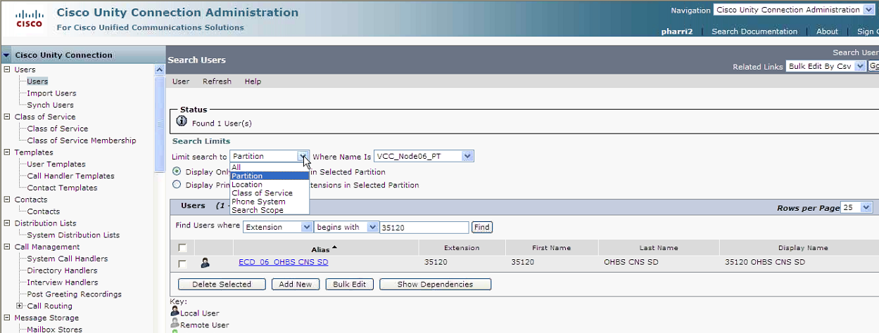

- Once page updates from the drop down ‘Where Name Is’ select VCC_Node11_PT as shown below:

Note: We are selecting Node 11 here as this is where we need the voicemail configured for this example Work Intake.

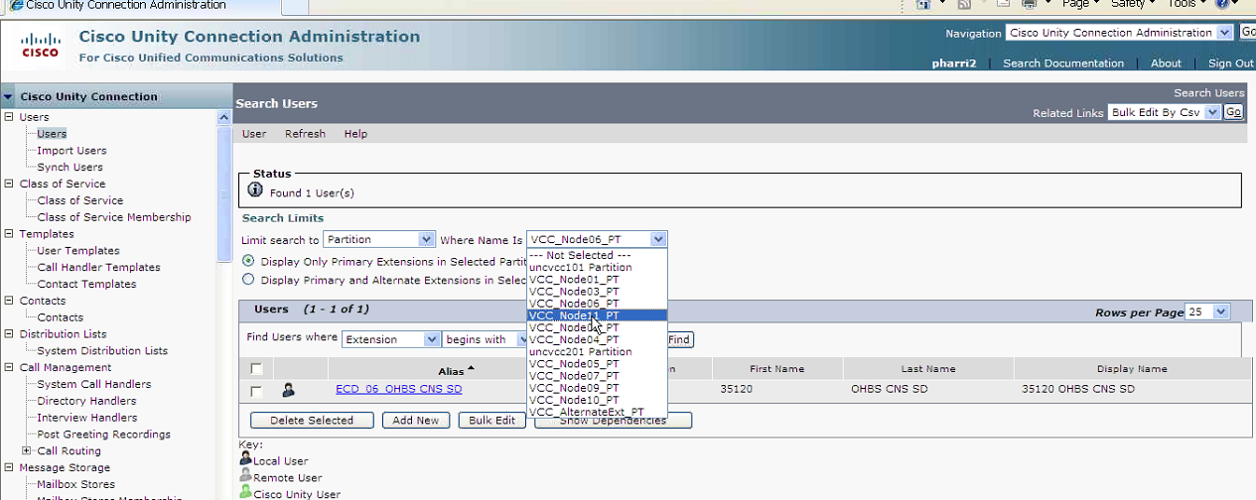

- In the ‘Find Users where’ enter in the VDN and select Find as shown below.

Note: This VDN will be the VDN that the Skill is configured on. In the case of this Work Intake it is VDN 3020240.

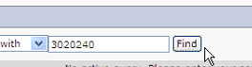

- This just verifies that nothing exists currently for this VDN.

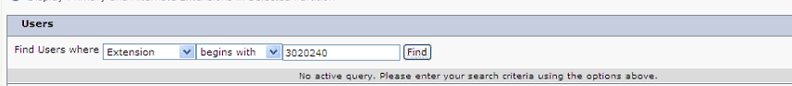

- Select New User from the User drop down menu as shown below.

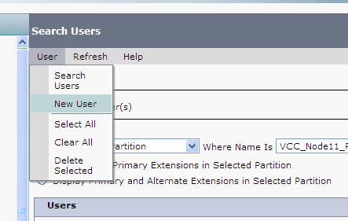

- Fill in the details as below for VDN 3020240. Details will be based on what Node, VDN and Business segment you are creating voicemail for.

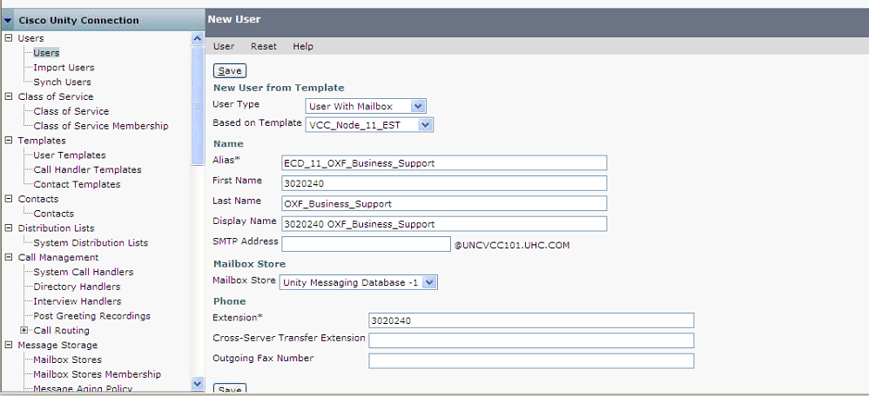

- Hit Save

- The voicemail is now created.

Note: Skill 90 is Voicemail on all Nodes as shown below.

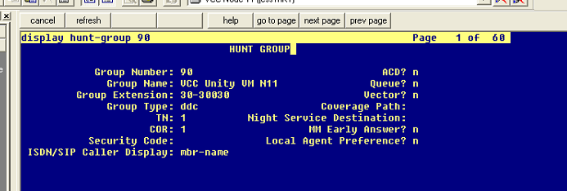

- Voicemail is then configured on the Vector like below:

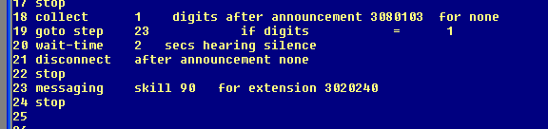
- An announcement is played, user hears ‘to leave a message please press 1’ or something similar. User presses one and is directed to step 23 which triggers the voicemail setup we configured above.

